A Project **Report** (including **Synopsis)** on

**Arrey! Bhai**

**E-commerce Website**

Submitted to Manipal University, Jaipur

Towards the partial fulfillment for the Award of the Degree of

**BACHELORS OF TECHNOLOGY**

In Computer Science and Engineering

2019-2023

By

Sarthak Ahuja & Shivansh Syal

(199301246 &199301241)



Under the guidance of

Dr. Ankit Shrivastava

**Department of Computer Science and Engineering**

**School of Computing and Information Technology**

**Manipal University Jaipur**

**Jaipur, Rajasthan**

**INTRODUCTION**

We’ll be building an e-commerce shopping website with html, css, javascript, bootstap and php with its backend on MySQL. Today, we know how popular online shopping has become all over the world, even in countries like India. Especially after this pandemic, most people might just prefer shopping online much over offline. In our website (**ArreyBhaiBhai**), customers will be able to add items in a virtual cart while surfing the website for products, and will be able to check out, and have the option of paying online/offline, just like the other shopping e-commerce giants like Flipkart and Amazon.

**MOTIVATION**

The incredible success of e-commerce giants like Flipkart and Amazon in India was certainly inspiring. And especially now, post-pandemic, they are expected to play a much bigger part in common peoples’ lives, not just because the physical shops are closed, but also because people have become more comfortable and somewhat reliant as well, on online shopping. So, the ongoing lockdown period felt like a good time to start a project like this. Also, the website will offer a very convenient and simple interface for the general customer to shop on ArreyBhai. From the both of us (Shivansh and Sarthak) under the guidance of our professor (Dr. Ankit Shrivastava), we hope this project is a success and helps common people with getting all kinds of stuff in their daily lives with ease!

**PROJECT OBJECTIVES**

The major objective, as already stated, is to get a major e-commerce shopping website up and running, which will be particularly helpful in the times of coronavirus pandemic, to make it easier for the common people to get stuff in their daily lives. It’ll have a relational MySQL database at the backend.

Through this project, we can even **potentially attempt to get offline shopkeepers to sell online, through us**, at ArreyBhai. This would encourage lesser physical interaction of people at physical shops, and not just that, but it’ll also make things more convenient, for both the customers and the shopkeepers. We will also set up digital payment options, which will further the convenience in general.

|  |  |
| --- | --- |
| PROS | CONS |
| More and more offline shopkeepers will be able to sell products online.  Easier for customers to get stuff in their daily lives. | The website is not completely hacker/malware attack proof. There are some potential backdoors, especially in the payment gateway. |

**PLATFORM USED**

**Front-End**

(i) HTML5

(ii) CSS3

(iii) JavaScript

**Back-End**

(i) PHP

(ii) MySQL

**Key Features**

Public User

(i) View Product

(ii) Create User Account

**Signin User**

(i) Search Product

(ii) View Product

(iii) Create Order

(iv) Change Email & Password

(v) Can View Previous Order with UPDATE and DELETE

**Admin**

(i) Add New Product

(ii) Update Product

(iii) Delete Product

(iv) Confirm Order

**ENTITY RELATIONSHIP DIAGRAM**

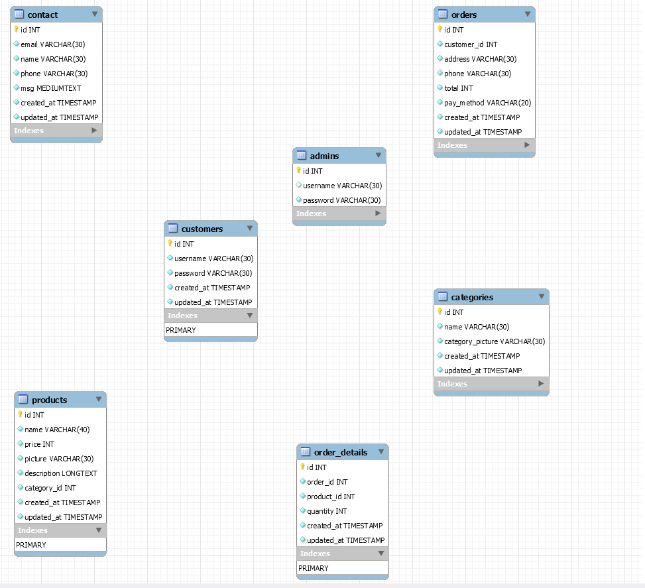

**TECHNOLOGIES USED**

* MySQL
* HTML
* CSS
* JavaScript
* Bootstrap
* PHP
* Apache

**PROJECT REPORT**

**ABOUT**

* It is a responsive webpage containing nice animations.
* Contains a well authenticated contact, login and sinup froms.
* A well developed product page
* Website info pages like About and Contact pages
* Contains many categories regarding clothes.
* A nice Footer.
* Authenticated Payment Page.
* A nice cart page

1. **THE WEBSITE**

Repo link: <https://github.com/sarthakahuja07/arrey_bhai>

Here are some screenshots of the website we could build so far:

Home page – Here you can land on 4 different main pages based on your selection i.e. Shop, collections ,about, contact and also choose products

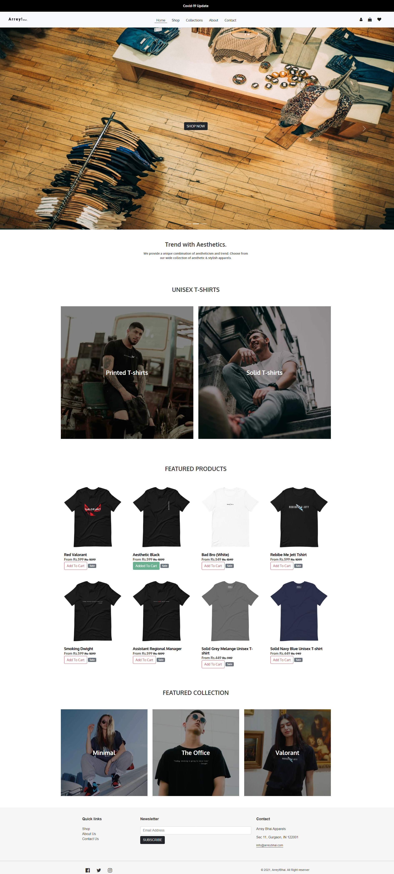

Products page

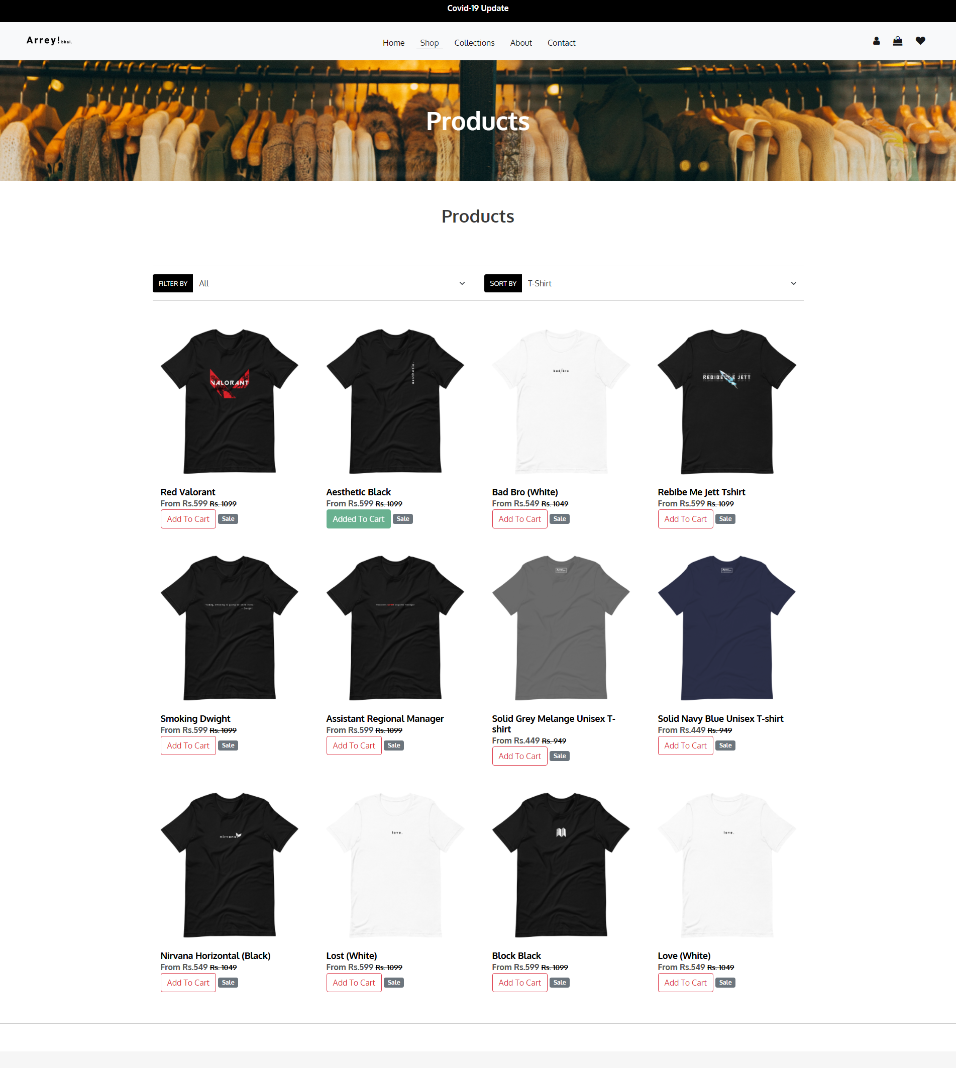

Collections page- here you can navigate through various categories of products in the basis of your choice.

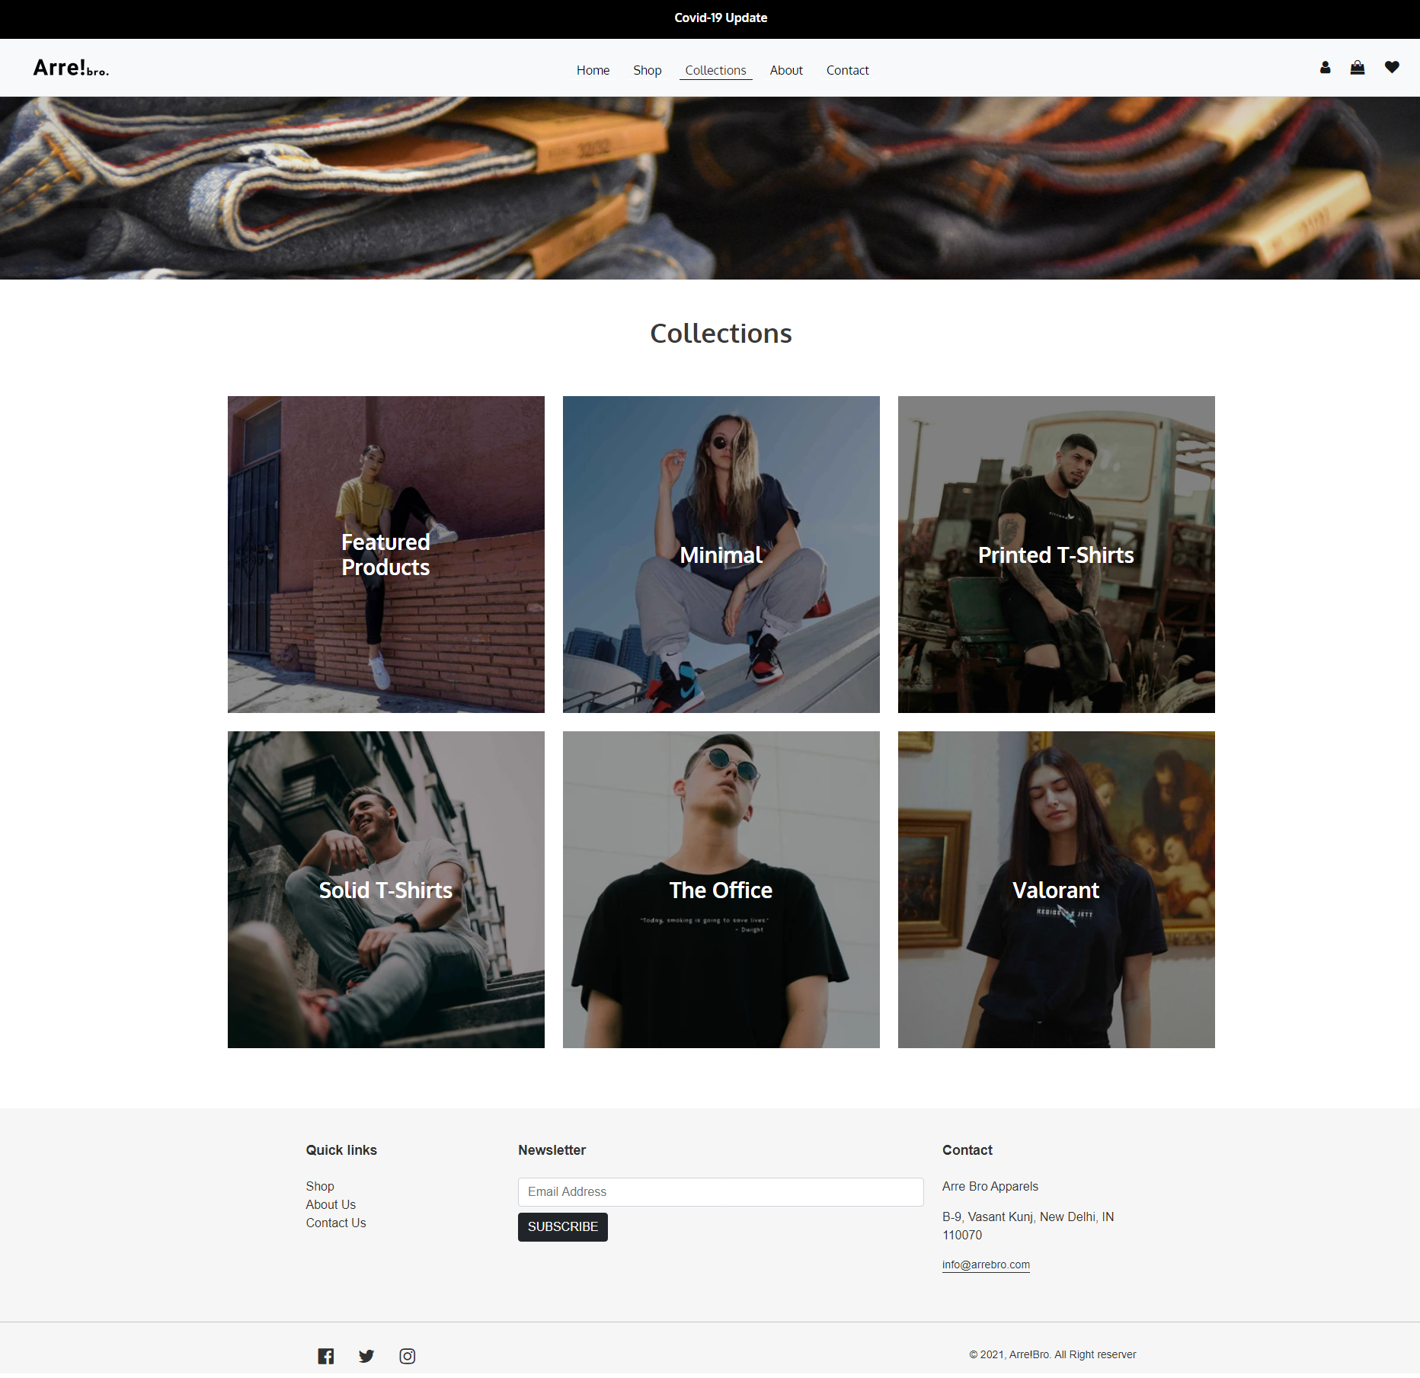

About page

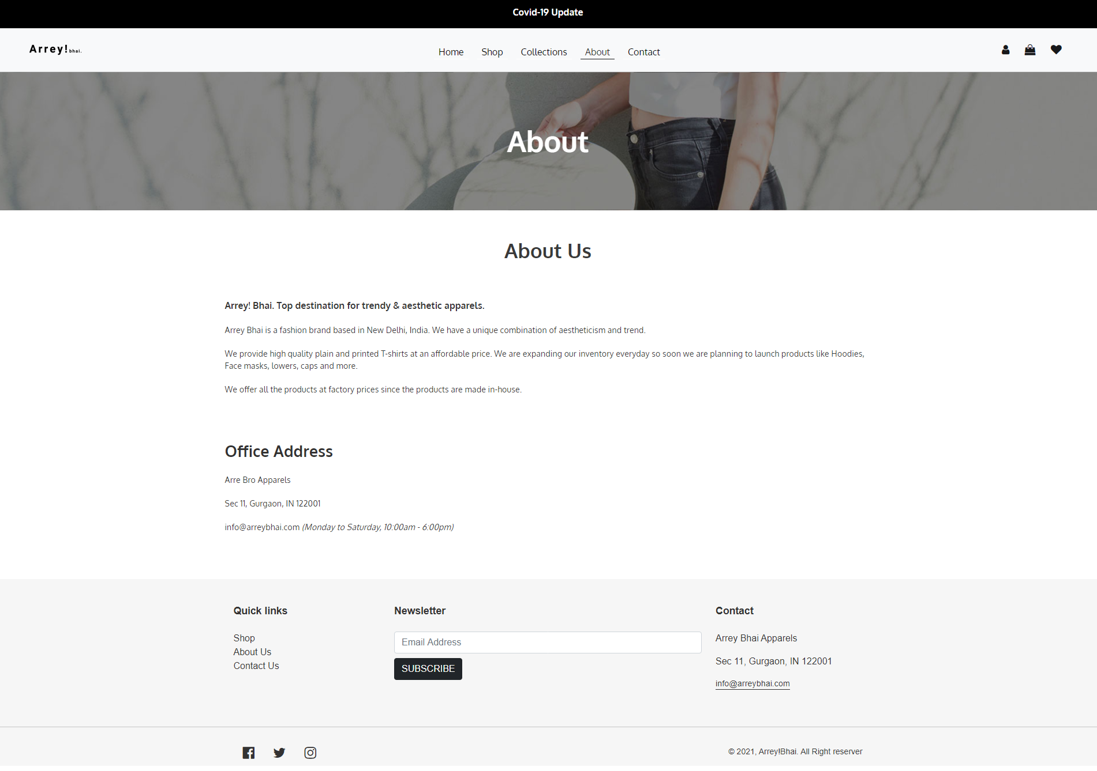

Contacts page

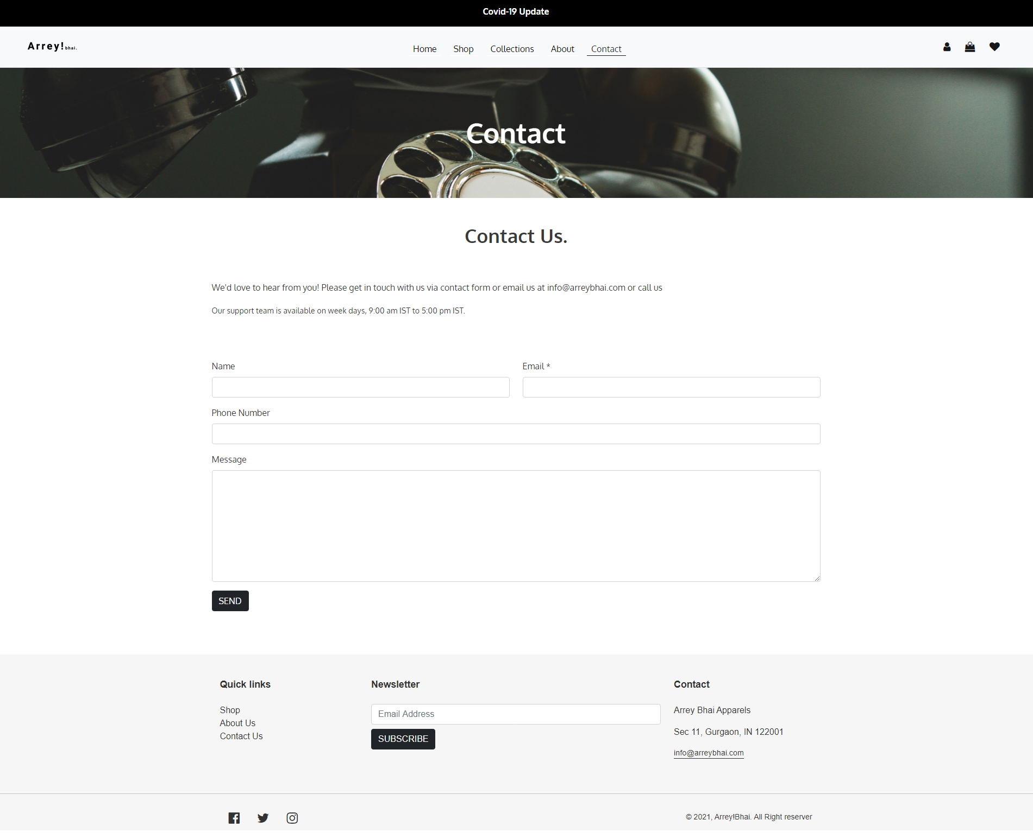

Covid-19 update page

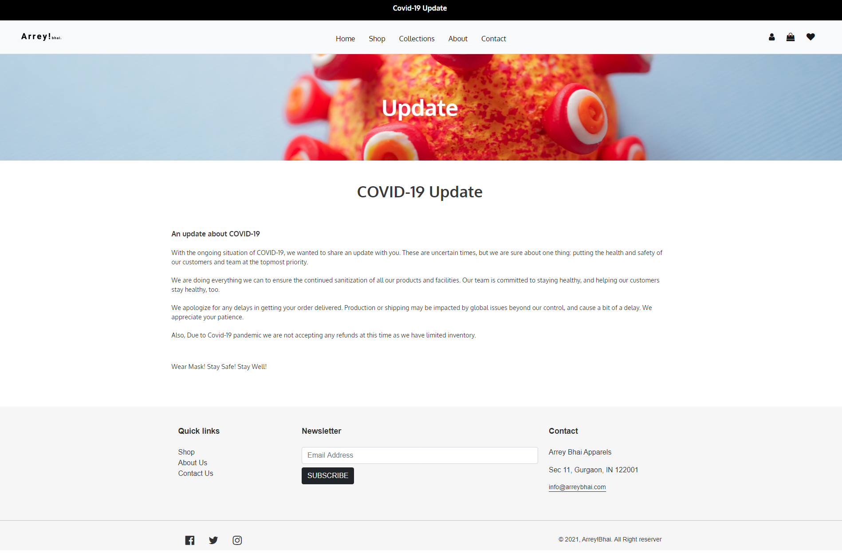

Login page

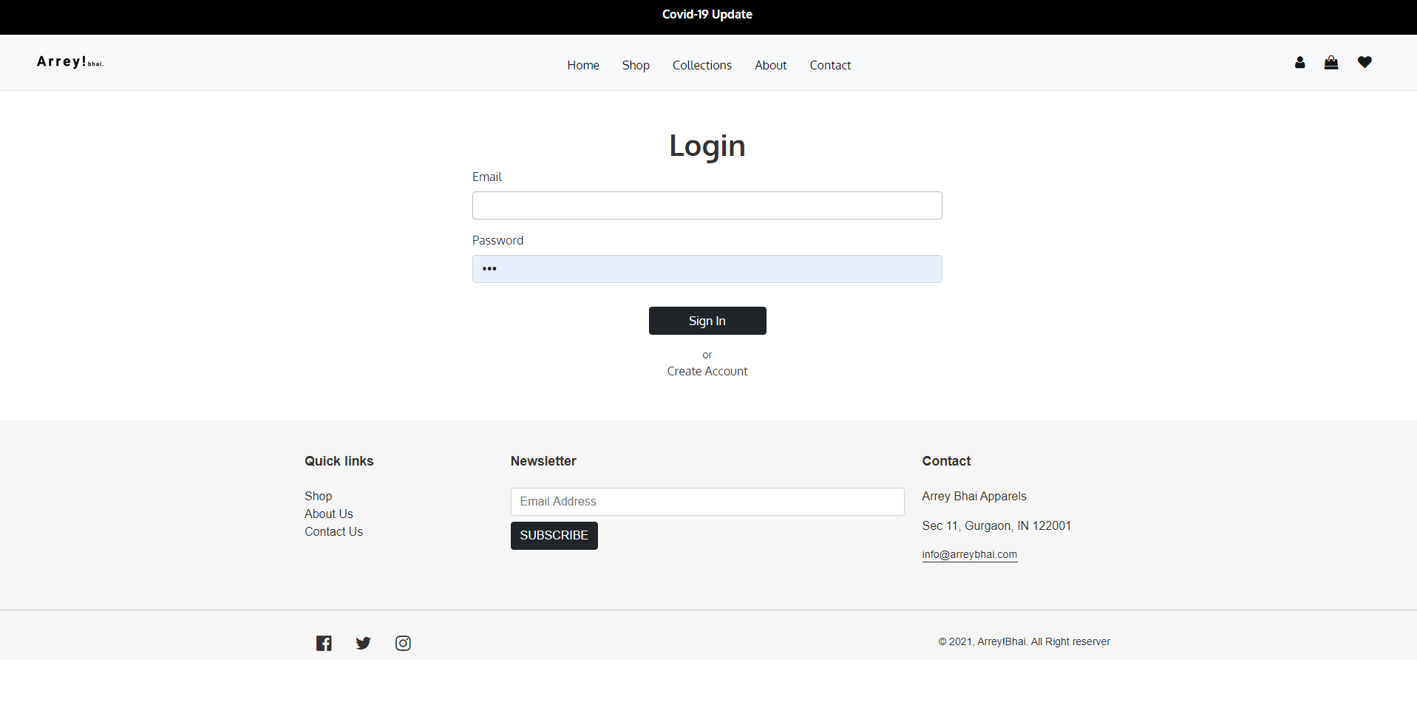

Account Creation page

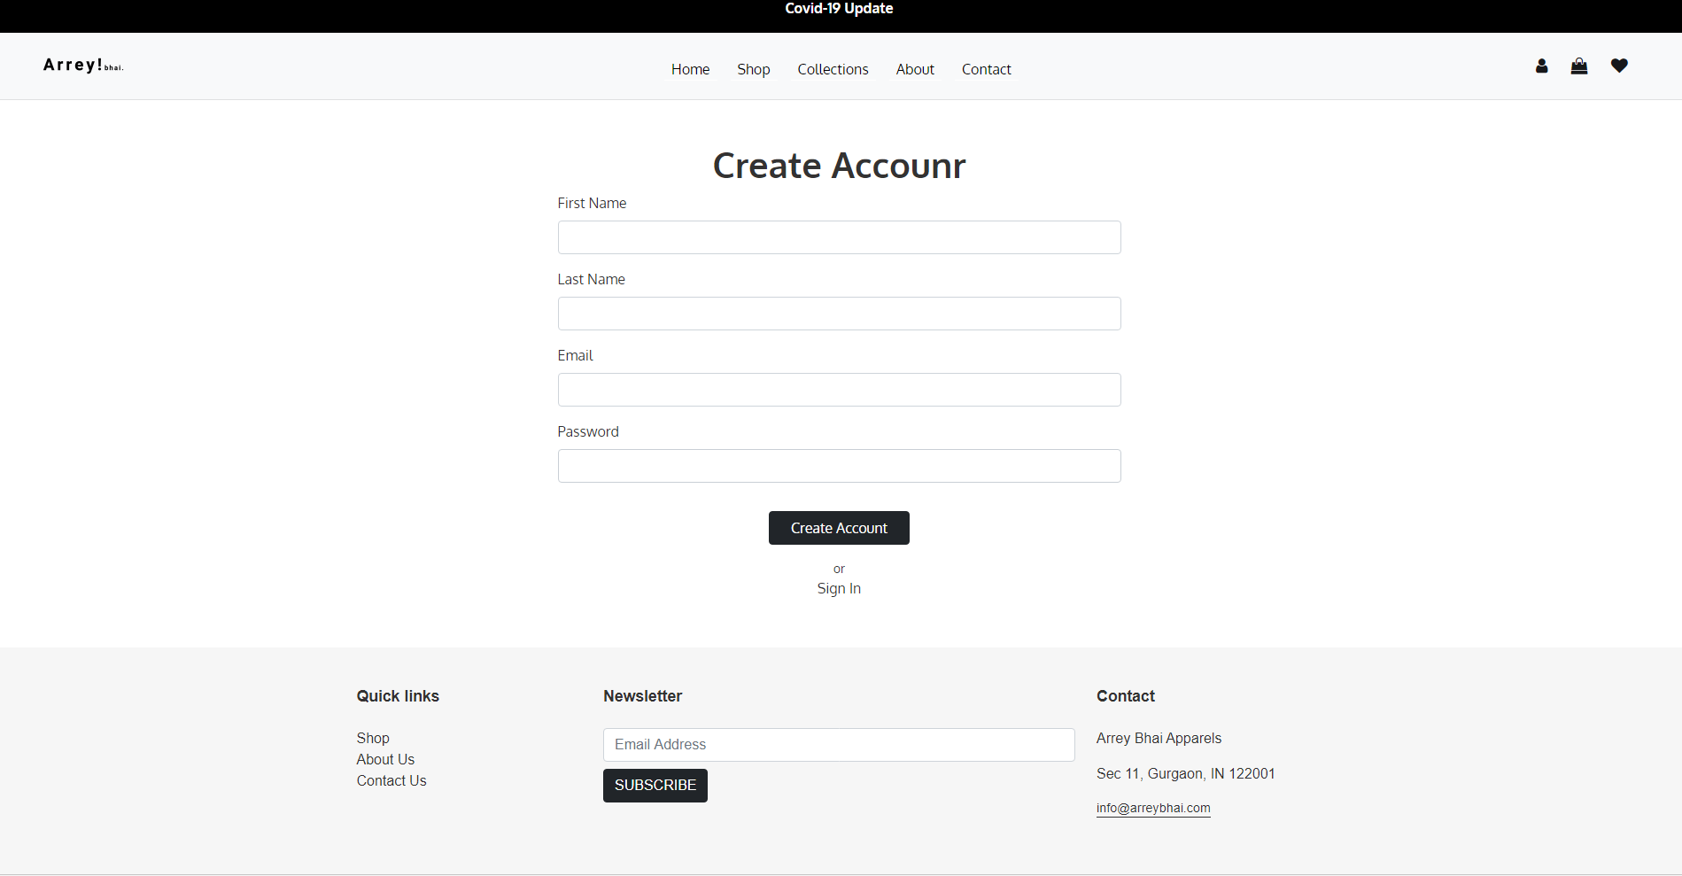

Cart page

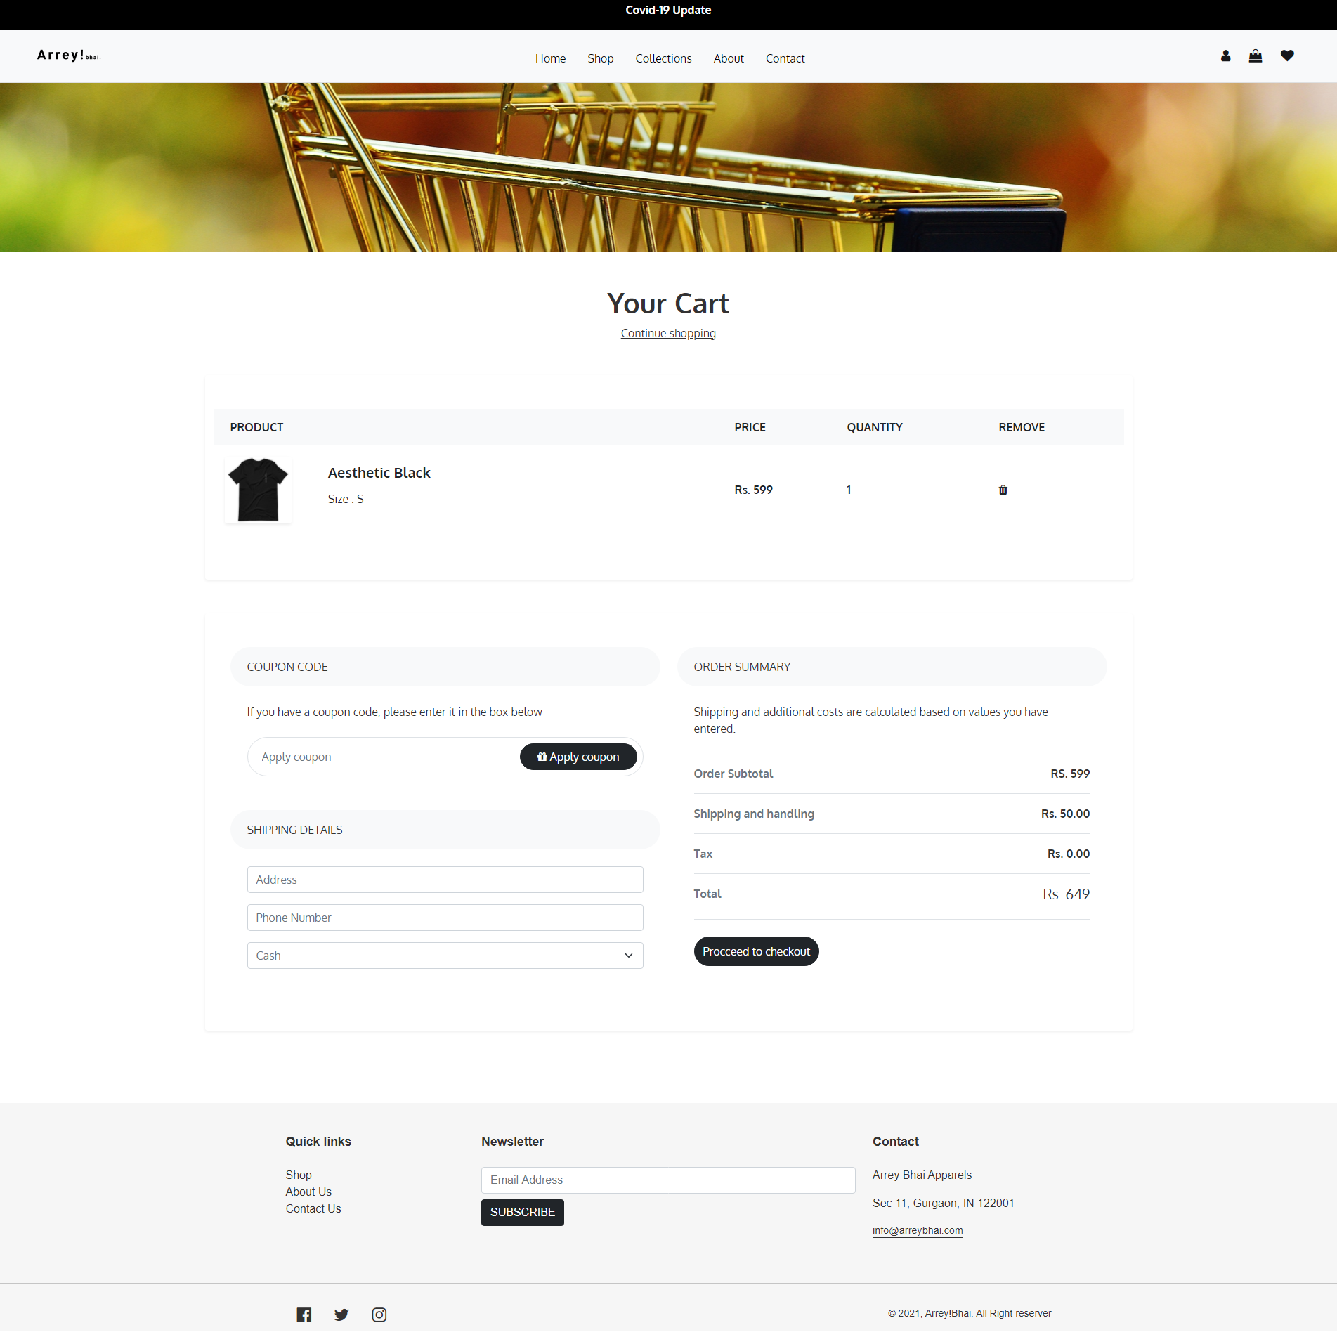

Admin login page



Admin pages:- for adding and removing products and accessing order details. 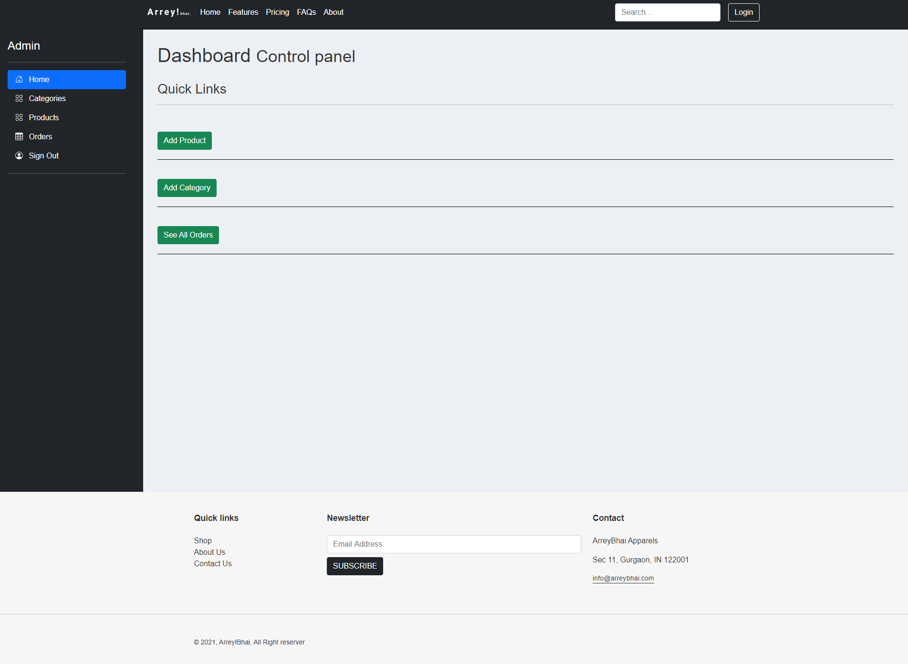

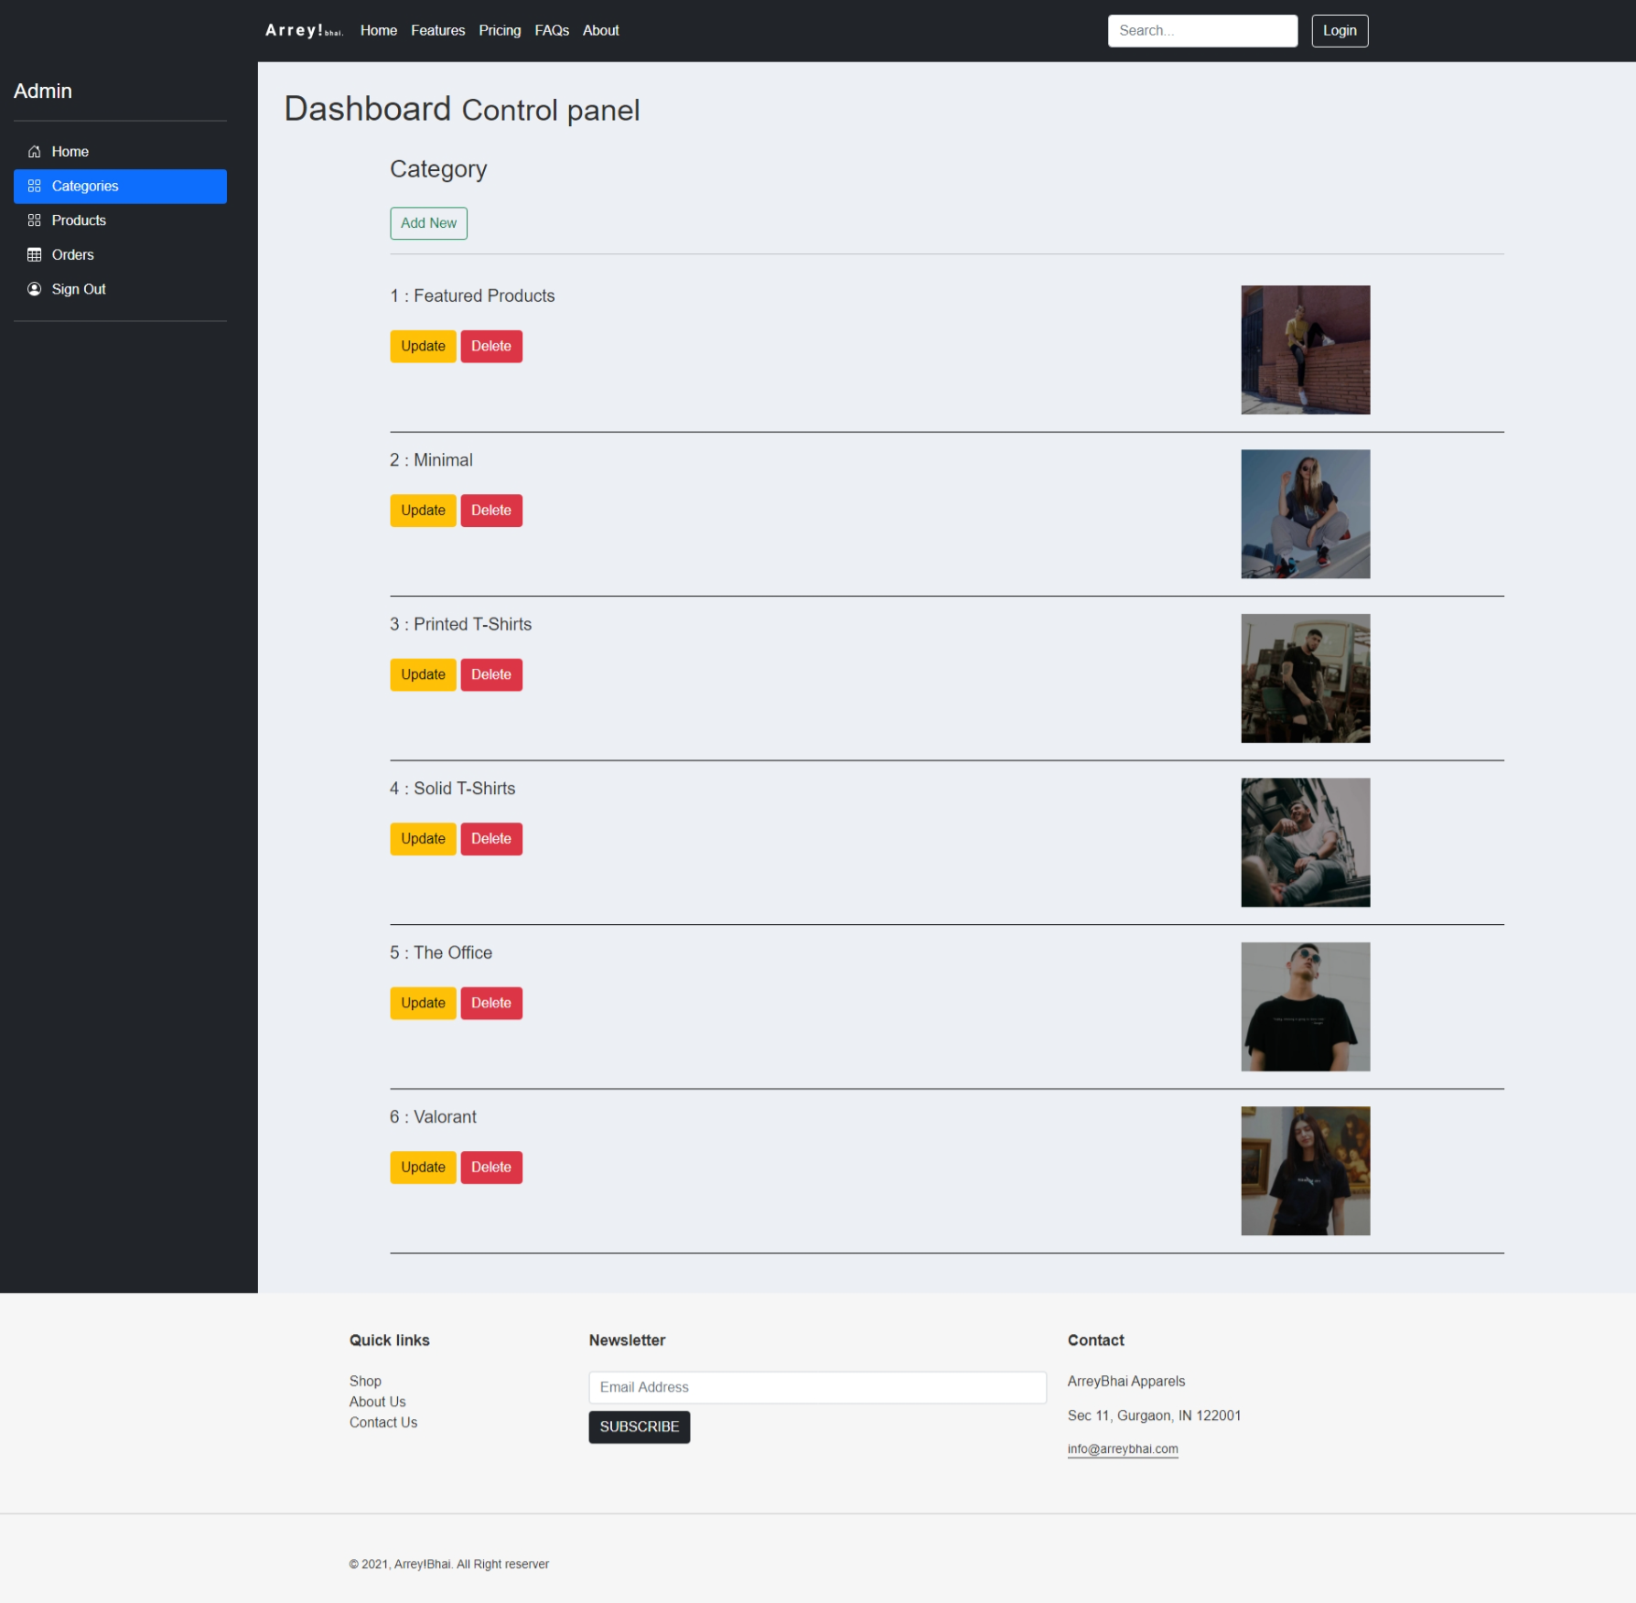



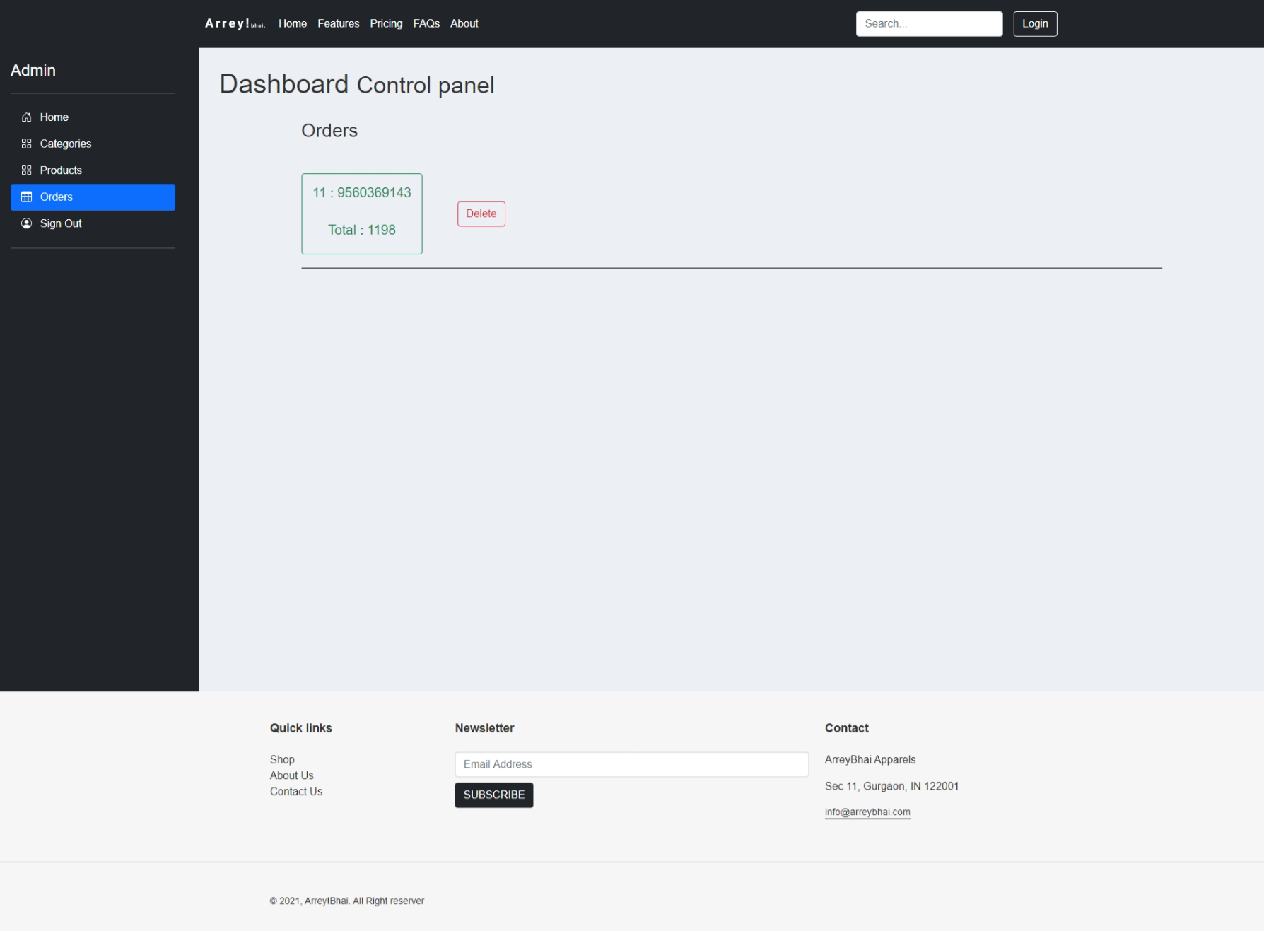

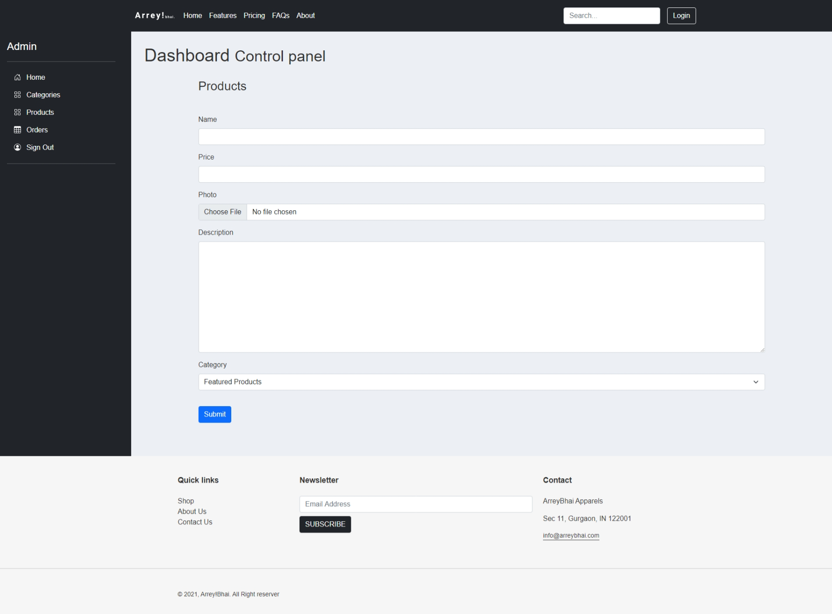

**CONCLUSION**

A simple E-commerce website built with HTML, CSS, JavaScript, PHP, and MySQL. This is a project created for my WebTech lab project and understanding of web deveplopment concepts and technologies that are essential to build a basic, working website.

we have successfully finished implementing the database based on MySQL completely, and a lot of core functionalities of the website using **HTML**, **CSS**, **Javascript, PHP** and **Bootstrap** The idea is to build a comprehensive, fully functioning online shopping website. We’d like to thank our professor for his due guidance in this project, and throughout the course.

**DECLARATION**

I hereby declare that the project entitled **“*_Arrey! Bhai: E-commerce Website***” submitted as part of the partial course requirements for the course _***Web Technology Lab***__, for the award of the degree of Bachelor of Technology in Computer & Communication Engineering at Manipal University Jaipur during the _***4th*** semester, has been carried out by me. I declare that the project has not formed the basis for the award of any degree, associate ship, fellowship or any other similar titles elsewhere.

Further, I declare that I will not share, re-submit or publish the code, idea, framework and/or any publication that may arise out of this work for academic or profit purposes without obtaining the prior written consent of the Course Faculty Mentor and Course Instructor.

Signature of the Student:

*Sarthak Ahuja and Shivansh Syal*

**BIBLIOGRAPHY**

<https://www.coursera.org/learn/database-applications-php>

https://www.coursera.org/learn/sql-for-data-science